# Kickstart for SQL Server & SQL Database

In this article, we will go, step by step, to create SQL Server & Database on Microsoft Azure. Microsoft Azure SQL Database (formerly SQL Azure, SQL Server Data Services, SQL Services, Windows Azure SQL Database) is a cloud-based service from Microsoft, offering data-storage capabilities. The aim is for users to just communicate with a T-SQL endpoint rather than managing database storage, files, and high availability.

Current versions of Microsoft Azure SQL Database share a common code-base with Microsoft SQL Server. This database engine allows users to make relational queries against stored data which can either be structured or semi-structured, and unstructured documents.   
  
SQL Database features include, querying data, search, data analysis, and data synchronization. High availability is provided by storing multiple copies of databases. Business continuity and disaster recovery is provided by backups and geo-replication, elastic scale, and rapid provisioning. Also, it has built-in data protection and security features.  
  
**Prerequisites**

* Microsoft Azure Subscription (MSDN subscribers or[sign up](https://azure.microsoft.com/en-us/free/) for one month free trial)

You will learn the following:

* How to create SQL Server
* How to create SQL Database

**Getting started with SQL Database  
  
Step 1:** Navigate to [Azure Portal](https://portal.azure.com/) & Sign in with Microsoft Azure credentials.  
  
**Step 2:** Click on +New -> Data + Storage -> SQL Database.  
  
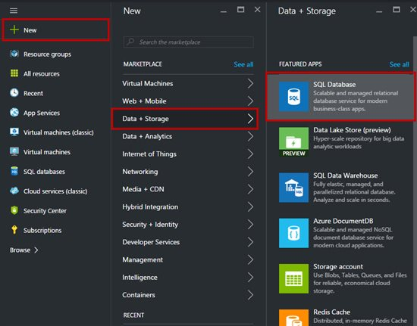  
   
**Step 3:** Enter the SQL **Database Name**, choose **Subscription**, and select **Resource Group**: Create New or Use Existing.  
  
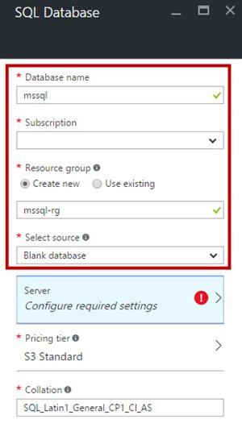   
**Step 4:** Now, it is time to create Server for database. Click on **Create a new server**option. Again, enter Server Name, Server Admin, Password, and Location.  
  
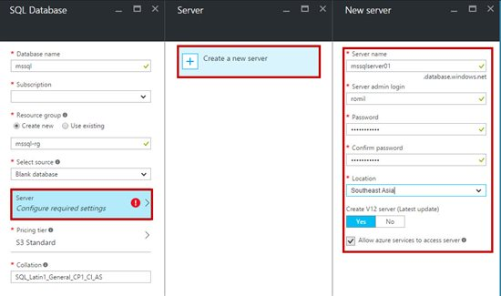  
  
**Step 5:**Choose Pricing Tier from Basic, Standard or Premium.  
  
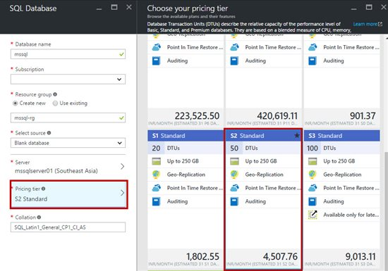  
  
**Step 6:**Summary of the SQL Database options is available below:  
  
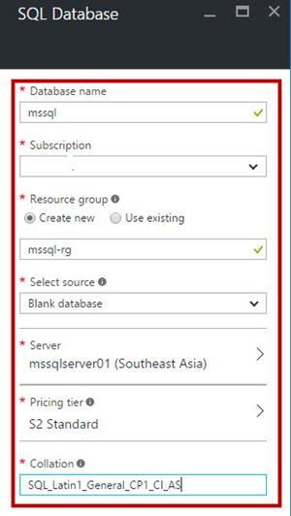  
   
**Step 7:**Wait for a few seconds to let the SQL Database on Azure get created. To use SQL Database in the application, we need to use connection string. All connection strings for other databases, such as ADO.NET, ODBC, PHP, JDBC, can be seen here,  
  
